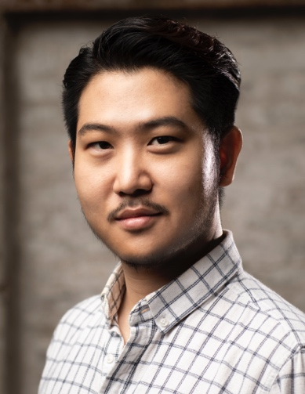
KYU CHOI
30 Bridge House,
18 St George Wharf,
London, SW8 2LP

+44 7988 080 730
kyuchoi814@gmail.com
DOB : 14 AUG 1990

BARITONE
www.kyuchoi.co.uk

EDUCATION
∙ 2019-2020 National Opera Studio, London
∙ 2017-2019 A.D. Royal Academy Opera, London
∙ 2016-2017 M.A. Royal Academy of Music, London, Vocal Studies & Performance (Distinction)
∙ 2010-2016 B.A. Korea National University of Arts (KNUA), Vocal Studies (2 years out for the national service)

PERFORMANCE
OPERA
∙ 2019 Iolanta - P. Tchaikovsky (Robert), Les Azuriales Opera Festival, France with Bryan Evans MBE
∙ 2019 Dead Man Walking – J. Heggie (Owen Hart: Cover), Welsh National Opera
∙ 2019 The Consul – G. Menotti (Assan: Cover), Welsh National Opera
∙ 2019 Iolanta - P. Tchaikovsky (Robert), Susie Sainsbury Theatre, London with Gareth Hancock
∙ 2018 Die Fledermaus - J. Strauss II (Dr Falke), St. Elisabethkirche, Berlin with Peter Leonard
∙ 2018 Le Docteur Miracle - G. Bizet (Le Podestat), Susie Sainsbury Theatre, London with Gareth Hancock
∙ 2017 Don Giovanni - W.A. Mozart (Don Giovanni), Hackney Round Chapel, London with Gareth Hancock
∙ 2015 Don Pasquale - G. Donizetti (Malatesta), KNUA Grand Theatre with Carlo Palleschi
∙ 2014 Don Giovanni - W.A. Mozart (Don Giovanni), Incheon Culture and Art Centre with Carlo Palleschi
∙ 2014 L'elisir d'Amore - G. Donizetti (Belcore), KNUA Concert Hall with Carlo Palleschi
∙ 2011 Die Fledermaus - J. Strauss II (Frank), KNUA Grand Theatre with Paul Weigold

ORATORIO
∙ 2018 St John Passion - J.S. Bach (Jesus), Petersfield Festival Hall with Paul Spicer
∙ 2017 Elijah - F. Mendelssohn (Elijah), Buckingham Parish Church with Julian Mann
∙ 2017 Messiah - G.F. Handel (Bass Soloist), Buckingham Parish Church with Julian Mann

SCHOLARSHIP & AWARD
∙ 2019 The First Prize (Joaninha Award, UK)
∙ 2019 The Second Prize (Clonter Opera Prize, UK)
∙ 2019 The First Prize (Pavarotti Prize, UK)
∙ 2018 The First Prize (VIII Nadezhda Obukhova International Singing Competition, Russia)
∙ 2018 Henry Wood Trust Award (Royal Academy Opera)
∙ 2018 Independent Opera at Sadler’s Wells Award (2 years)
∙ 2017 Charles Mackerras Opera Scholarship (Royal Academy Opera)
∙ 2017 Stokes Bursary (Royal Academy Opera)
∙ 2017 The Opera Prize (Mozart Singing Competition, UK)
∙ 2016 Josephine Baker Trust Award
∙ 2016 San Martino Scholarship (Royal Academy of Music)

